Portable Atmospheric Electron Beam to
Remotely Deactivate Electronic Devices
(e-Zapper) FY2005 (U)

Professor James F. Ziegler
Electrical Engineering Dept.
United States Naval Academy
410-293-6168 Fax: 410-293-2218
Ziegler@USNA.edu

Professor Martin Nelson
Mechanical Engineering Dept.
United States Naval Academy
410-293-6427 Fax: 410-293-2218
Nelson@USNA.edu

(See Appendix for other participating geniuses)

Award: N001405WR20071

LONG-TERM GOALS
The goal of this project is to neutralize bombs with electronically controlled detonators by deactivating their electronics without detonating the explosives. This project is applicable to remotely controlled road-side bombs, explosives with electronic delay timers and unexploded bombs with electronic safe and arm (ESA) fuses. Previous work has shown that only high energy electro-magnetic pulses (EMP) and electron beams are capable of such neutralization. Since EMP pulses are easy to shield against, work has concentrated on using high energy electron beams with stand-off ranges of hundreds of feet.
The goal is to build and test a prototype e-beam tool, capable of being transported in a humvee type vehicle, which has a range of at least a hundred feet and a beam density adequate to deactivate moderately shielded electronics within a few seconds. This tool has the nickname “e-Zapper”.

OBJECTIVES
The objectives are in three parts:
(1) Research to develop and characterize e-beam technology suitable for a portable e-Zapper.
(2) Testing of the e-Zapper on various electronics and explosives to demonstrate the ability to deactivate electronics without detonating attached explosives.
(3) Build a portable e-Zapper and demonstrate its use in field experiments.

APPROACH
The initial approach will be to survey available e-beam accelerator technology. Develop technology to bring the e-beam out into the atmosphere (which is rarely done). Develop methods of characterizing the e-beam in air. Test the e-beam on various electronic targets to find the minimum energy and dose required for neutralization.
Once the required beams can be obtained, methods will found to miniaturize the e-Zapper components so they can be made mobile and field hardened. A prototype e-Zapper will be built mounted in a towable trailer. Finally, field tests will evaluate the e-Zapper on actual detonator electronics and explosives.

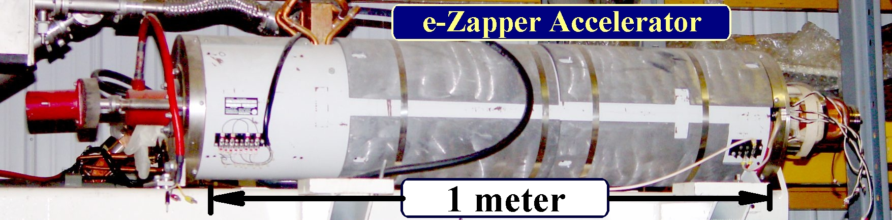
Figure 1 – Electron accelerator used in current e-Zapper tests
The photo shows the electron accelerator used in the tests described in this report. It creates an electron beam with energies up to 18 MeV, which exit from the 3mm tube at the left. The accelerator is an RF linac, capable of producing more than 10mA (DC equivalent) of electrons at the maximum energy.

WORK COMPLETED (RESULTS)
- Initial tests were run on various electronic timers using a non-vacuum 3 MeV electron beam. It was shown that a 10μA/cm² beam would destroy the electronics within one second.
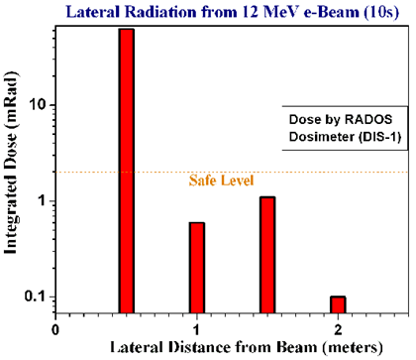
- A suitable e-Zapper was identified using 20 MeV electron accelerators manufactured for use in hospitals for radiation-oncology treatments. Used machines were available which could be converted to test the e-Zapper concepts.
- A non-vacuum Faraday cup was designed and built for measurements of electron beams in air with currents below 1μA. Tests showed an accuracy of better than 5%.
- A test site was established in Newark, OH, for testing and for development of technology for non-vacuum e-beams.
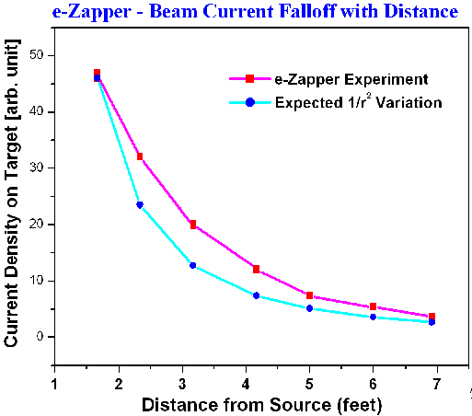
- Extensive calculations were performed to establish safe operating procedures for the non-vacuum e-beam. Operational approval was obtained for experimental operation from the Department of Radiation Safety for the state of Ohio.
- A non-vacuum e-beam was obtained, and its radiation and dispersion were measured. No significant transverse radiation was measured more than 1m from the beam axis. Dispersion of the beam followed an inverse square of distance, suggesting limited dispersion from the air itself. This is in agreement with calculations. Beam diameter at 1’ was shown to be less than 1cm (hold burned in plastic).
- Tests were run on the following electronics. All devices were destroyed in less than 5 seconds of exposure (<300 nC/cm² total beam):
    - 4 ea - walkie-talkies with “call alarms” (Bell South #2250).
    - 2 ea – house door-bells with remote RF switches (GE #1602)
    - 2 ea – house door-bells with remote RF switches (Heath #SL-6195-RX)
    - 2 ea – auto siren alarms with remote RF switches.
    - 1 ea – model airplane RF controller (Top Qualifier)
    - 1 ea – Infrared motion detector (Paradox #DG65)

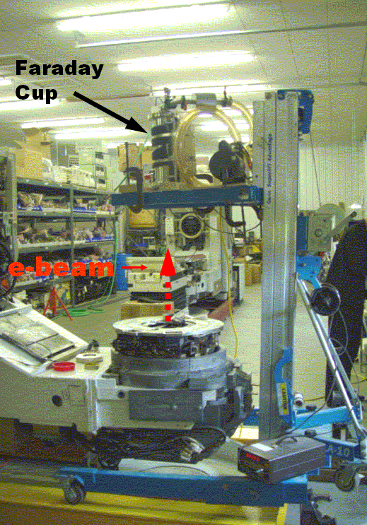 | 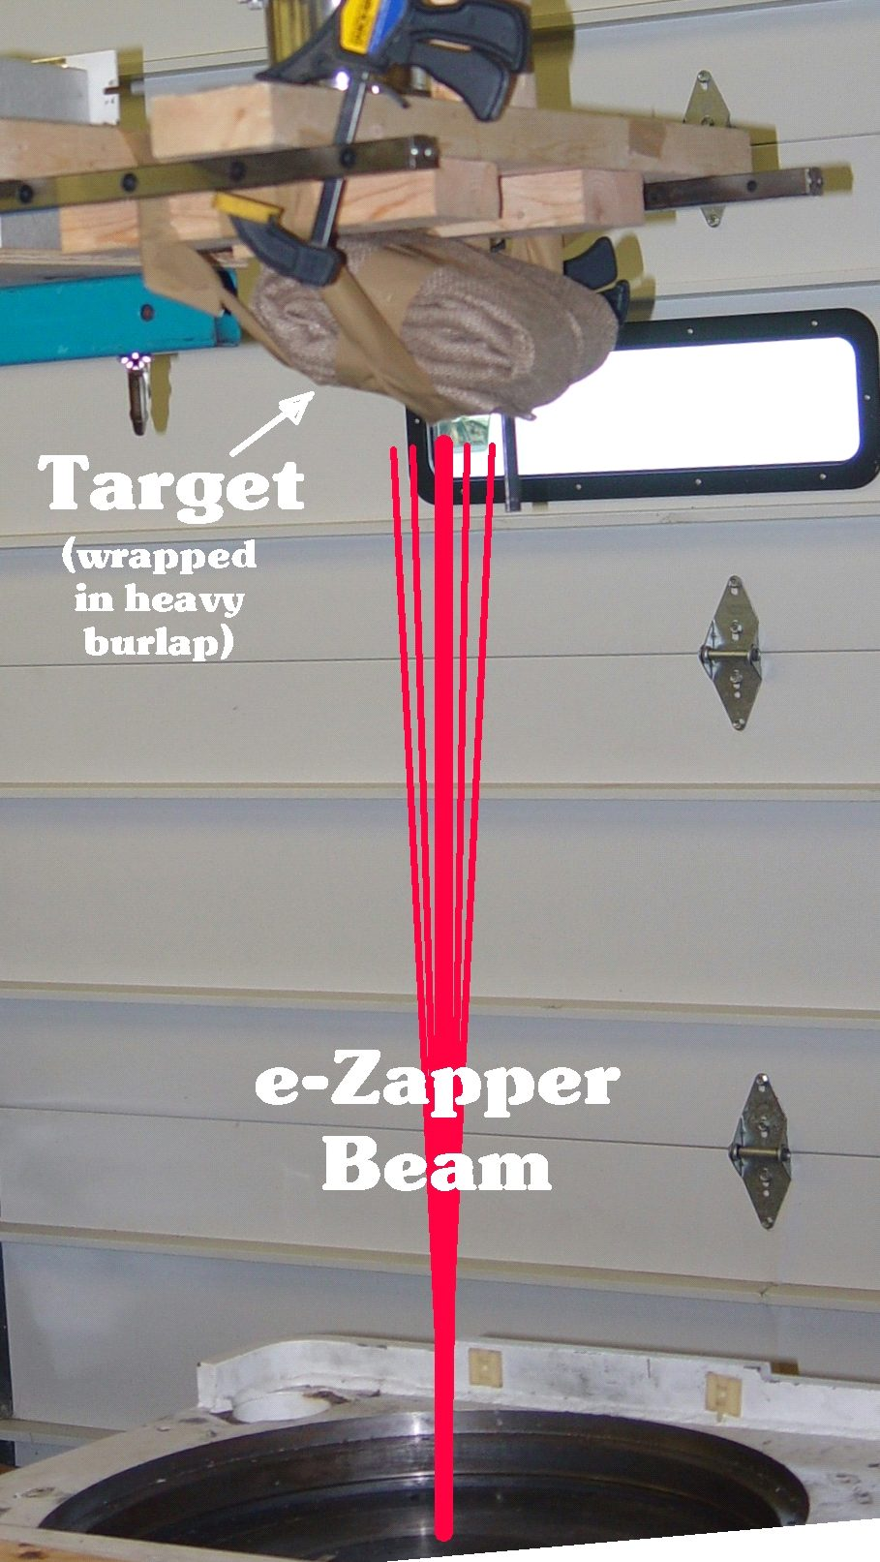
Figure 2 – Experimental e-Zapper Setup
The left photo shows the accelerator head which emits the e-beam into the air in a vertical direction. Above this is a Faraday Cup, adjustable in height up to 10’. The Faraday Cup is accurate to better than 5nC. The right photo shows a typical target (here it is a household door bell with a remote RF switch. The target is wrapped in 6 layers of heavy burlap to simulate typical road-side bombs.). The electronics were destroyed within 5 seconds using a beam of about 40 nA/cm² (DC average). This test setup used a greatly reduced beam current. The accelerator is capable of producing more than 100,000 times the beam current used in these experiments.

- A test was also run with explosives. An “auto siren alarm” with remote RF switch was placed behind 3 shot-gun shells and one cylinder of 3cc of black power. Electronics were destroyed within 3 seconds, without detonating any of the explosives.

IMPACT
The e-Zapper destroyed all of the above electronics with beams of less than 300 nC. The initial tests of surrounding the e-Zapper target with simple explosives showed no detonation. Prior published studies concerning e-beams and explosives indicated only the heating effect of the beam was a factor in initiating detonation, always at temperatures above 200ºC. (See citations listed in Appendix.) For a high energy 10μA/cm² beam, the dilute heating should barely raise the explosive material above room temperature. Radiation measurements during the e-Zapper experiments in killing the various electronic devices showed no significant radiation (<<2 mRem/hr) at one meter away from the beam. This correlates with the extensive radiation exposure calculations described below.
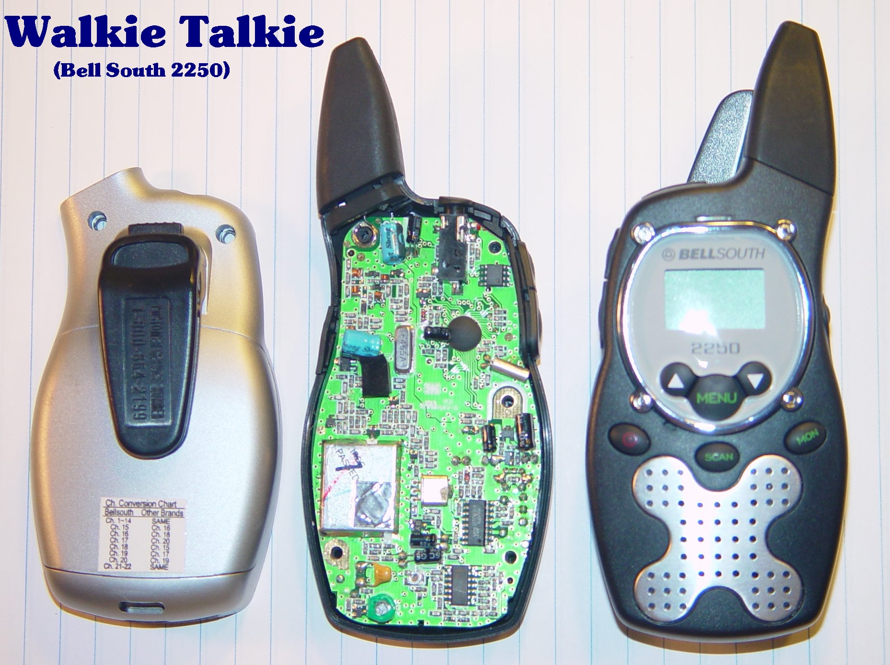 | 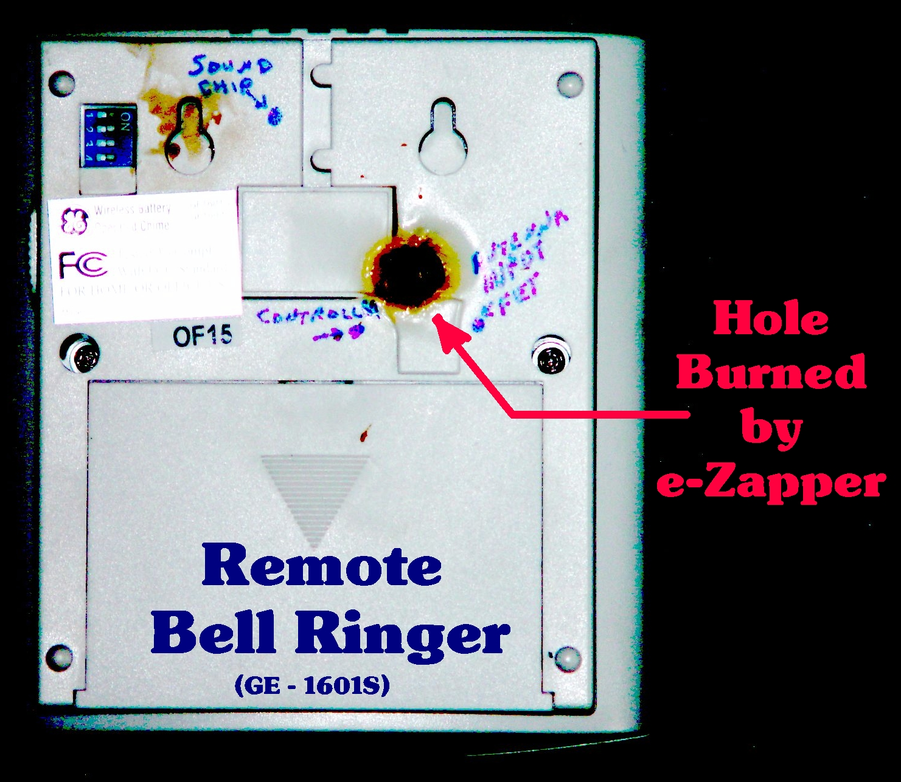
Figure 3 – Typical e-Zapper Target  Shown above is a typical e-Zapper target used in the reported experiments. This is a walkie-talkie with a quoted range of 2 miles. It has both a bell alarm and a LED alarm, either of which could be rewired to activate a micro-relay connecting a battery to a detonator. The walkie-talkie has three primary chips, any of which could disable it. The walkie-talkies were killed in <5 seconds using about 50 nA/cm² of e-beam intensity. | Figure 4 – e-Zapper Beam Diameter  One target was placed about 1’ from the e-beam exit aperture during initial setup, and the beam instantly drilled a hole in the plastic housing. The melted plastic hole measured slightly less than 1 cm, indicating both the beam size and the potential beam power. (Noted on the case are the positions of three chips inside ringer case, which are required to activate the bell chimes.)

A complete analysis of the radiation produced by the experimental setup was required for the Dept. of Radiation Safety of Ohio. These calculations were based on NCRP Report #51 (see citations). The setup is shown in the schematic, Figure 5. The results showed non-significant lateral radiation from the beam transiting the air. Radiation from the e-beam hitting the ceiling of the building of the test room (the beam was emitted vertically upward) also showed acceptable levels of back radiation into the test room. However, there was measurable “dark current” radiating downward from the electron accelerator. This radiation would hit the concrete floor and possibly produce the most significant radiation from the setup. This radiation was easily contained by building a shielding dam around this area, reducing this radiation to an acceptable level.
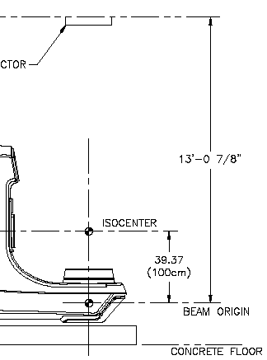
Figure 5 – Beam Setup for Radiation Calc.
Calculations were performed for the e-Zapper setup to determine expected radiation during preliminary experiments.

APPLICATIONS
The initial testing of the e-Zapper showed success in all benchmarks. The technology chosen for the e-Zapper is capable of deactivating electronics at a distance with very low doses of beam. The next step is to engineer a full-strength e-Zapper based on this technology, and to evaluate its characteristics.

The following items are specifically noted for the FY06 development phase:
- Develop a technology for extraction of the e-Zapper beam into the air with high efficiency and low dispersion. The use of a “Plasma Window” is expected to achieve this goal. This concept is relatively untried, but has the potential of allowing the development of an e-Zapper with maximum stand-off capability. The development of this component is expected to take 6-9 months. (See “Plasma Window” citations listed in Appendix.)
- Develop a differential pumping beam line which can provide a vacuum of 10⁻⁹ Torr from the electron accelerator’s source to the 10⁻⁴ Torr at the entrance to the plasma window.
- Develop a support system for all mechanical components of the e-Zapper which will also allow aiming of the beam at targets. The support system will be designed to be later mounted on an air-support trailer, which will allow movement of the e-Zapper to EOD test sites.
- Develop a laser alignment device for the e-Zapper, allowing precise beam motion towards a target.
- Evaluate and identify light-weight replacements for the electronic components required for e-Zapper operation. The current power supplies and RF amplifiers weigh more than 1400 lb, but replacements should reduce their weight by 70%. These new electronics will be identified from existing commercial products. The procurement of these electronics has not been included in the ’06 equipment budget.
The full-strength e-Zapper will be developed in FY06, and its characteristics will be fully documented. The most important goal will be the extraction of an intense beam through a high-efficiency window, and the measurement of the beam intensity at extended distances, as well as confirming deactivation of electronics at extended distances.
The design of a fully transportable e-Zapper will be completed, including a method of laser alignment. The electronics for the e-Zapper will be redesigned using compact low-weight components.
The transportable e-Zapper will be fully constructed in FY07, assuming all benchmarks listed above are met. Note that the purchase of replacement electronics is not included in the FY06 budget.

TRANSITIONS
None
RELATED PROJECTS
None

REFERENCES
Plasma Window
- “Air boring and nonvacuum electron beam welding with a plasma window”, A. Hershcovitch and Acceleron Team, Phys. of Plasmas, 12, 057102 (2005).
- “X-ray transmission through a plasma window”, B. T. Pinkoski, I. Zacharia, A. Hershcovitch, E. D. Johnson and D. P. Siddons, Rev. Sci. Instr., 72, 1677-1679 (2001).
- :Windowless Targets for intense beams”, D. Salerno, B. T. Pinkoski, A. Hershcovitch and E. Johnson, Nucl. Inst. and Methods, A469, 13-20 (2001).
- “A plasma window for transmission of particle beams and radiation from vacuum to atmosphere for various applications”, A. Hershcovitch, Phys. of Plasmas, 5, 2130- 2136 (1998).
- “The plasma porthole: a windowless vacuum-pressure interface with various accelerator applications”, W. Gerber, R.C. Lanza, A. Hershcovitch, P. Stefan, C. Castle and E. Johnson, Proceedings CARRI-98, AIP Conf. Proc. 475, 932 (1998).
Electron Beams and Explosives
- “Thermal Initiation of High Explosives with an Electron Beam”, A. Stolovy, E. C. Jones jr., J. B. Aviles jr. and A. I. Namenson, Naval Research Laboratory Report #8350 (1979).
- “Theory and Modeling of Thermal Reaction Propagation in Beam-Initiated Explosives”, J. B. Aviles jr., Naval Research Laboratory Report #6650-93-7357 (1993).
Radiation Generated by e-Zapper
- NCRP report #51, “Radiation Protection Design Guidelines for 0.1 MeV-100 MeV Particle Accelerator facilities”, March 1, 1977.

PATENTS
None
HONORS/AWARDS/PRIZES
None
APPENDIX
(1) Participating Scientists in e-Zapper Research
Steven Andrews
President and Chief Scientist
Technical Options Co.
213 Dayton Rd
Newark, OH, 43005
740-344-3630
SteveAndrews@TOptions.com

Kenneth Purser
Southern Cross Co.
360 N. Emerson Rd.
Lexington, MA 02420
781-956-6613
KPurser@shore.net

Harold Hughes
Manager of Solid State Devices, Code 6816
Naval Research Laboratories
4555 Overlook Ave., SW
Washington, D.C., 20375
202-767-2429
Hughes@estd.nrl.navy.mil

Philip Miller
Dir. Div. of Dynamics and Diagnostics, Code 920
Research & Technology Department
Naval Surface Warfare Center-Indian Head
Indian Head, MD, 20640
301-744-4106
MoillerPJ@IH.navy.mil

